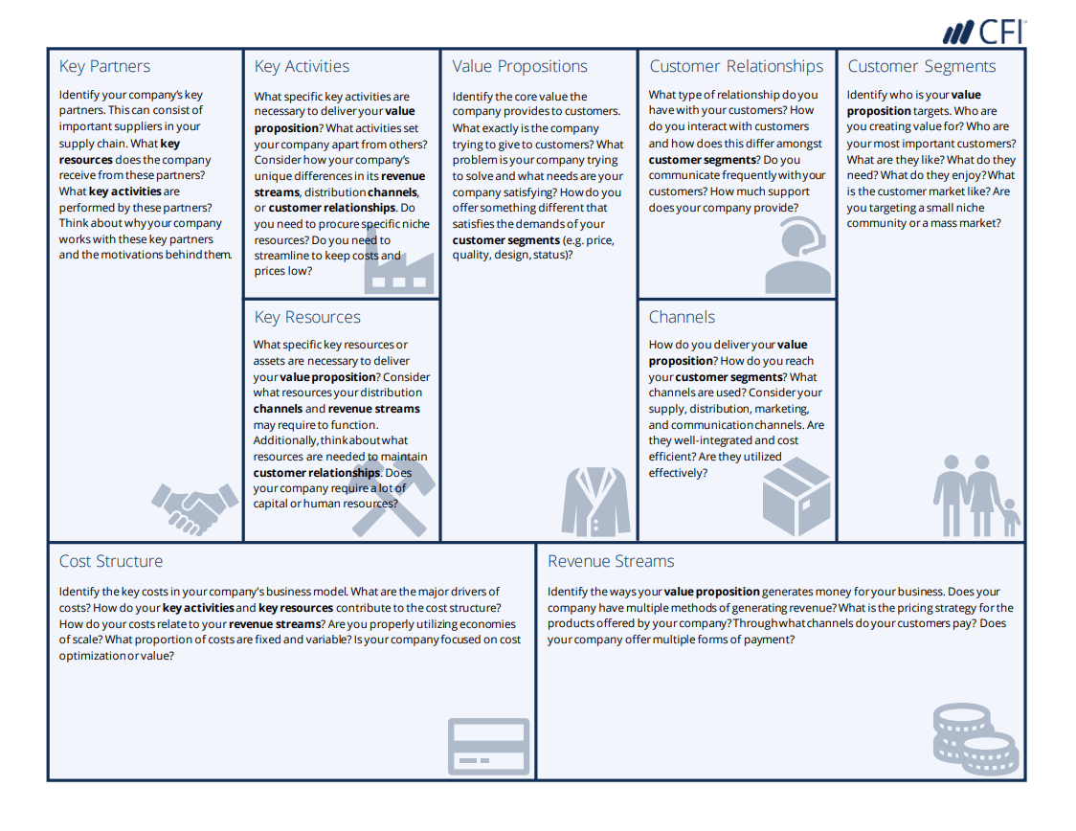

Key Partners:

* Community partner: Omar
  + Gives us feedback on our product
* Project Invent
  + Received funding ($500) from them last year
* Apply for grants from companies to get funding
* SLI
  + Need to use machines in lab
* Key resource: money/funding

Key Activities:

* Refine/Remake hat
  + Make sure cap works consistently and all the time
  + Make sure ultrasonic sensors and wiring cannot be seen
* Add-on features
  + Waterproof cap
    - Waterproof around the front and bottom of the bill
    - Waterproof ultrasonic sensors
  + Try to make customized circuit board
    - Not sure about this yet

Key Resources:

* Machines in the FabLab
* Funding from Project Invent
* Potential funding from grants/companies

Value Proposition:

* Help visually impaired people avoid colliding with overhead objects
* Help visually impaired people maneuver outside more easily and with comfort
* Try to make the cap affordable and less expensive than other products created for the same purpose

Key costs:

* Potentially building the circuit board
* Buying sensors and waterproofing material
* Buying a cap without a logo/ Buying a cap that is not connected to another company

Customer Relationships:

* Interact with Omar through Zoom and email
  + Maybe in person this year
* We communicated semi-frequently with Omar last year
  + Have not communicated with him this year

Customer Segments:

* Creating value for Omar
  + Original community partner
  + Needs to be able to walk around with worrying about bumping into anything
    - Walks around with his hand up in front of him
  + Has tried our prototype
    - Wants wiring and sensors to be less visible/invisible
    - Felt that the cap was comfortable
* Creating value for visually-impaired people

Channels: Later priority

* Manual channels to Omar later in the year
  + Mailing
  + Hand-to-hand

Revenue Streams:

* Only product is the hat
* Gain revenue by selling the caps